# EMERGENCY

**RESPONSE NUMBERS**

Superintendent Montaño: 505-379-1059

Terry Darnell: 505-220-3253

Sandy Darnell: 505-404-5682

Police/Fire: 911

BPS Administration Complex Evacuation Points

# EVACUATION POINTS

Locations indicated below are intended to be used for BPS administrative staff and visitors.

District Office Utility Cut-Offs

**EMERGENCY RESPONSE PROTOCOL**



### Lockout Lockdown



Evacuate Shelter

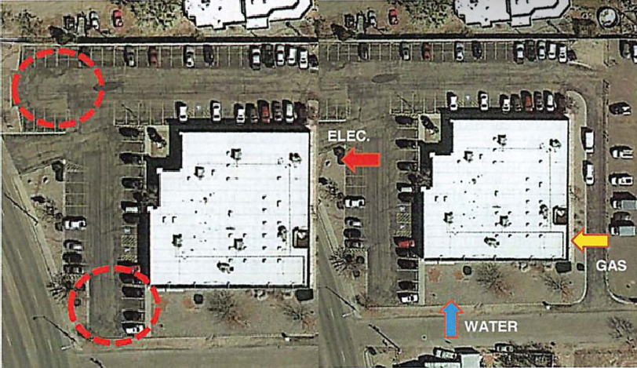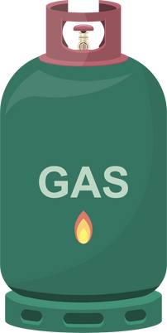

**Bernalillo Public Schools**



Why is this plan important?



### A strong safe school plan has a uniform response to any incident.

Weather events, fires (like the recent NM fires), threats of violence or otherwise are scenarios that are planned and trained for.

### In order for our schools to be on the same page, we use the same vocabulary to elicit a specific action that is standard throughout the district.

**What should I know?**

**Lockout - This is used when the potential threat is outside the school.**

Recover all students and staff from outside.

Secure the building perimeter by locking gates and outside facing doors.

Regular classroom and department business continues inside the building.

No movement between buildings. Communicate your location to your supervisor if outside of your normal working area.

## Lockdown - This is used when a potential threat is inside the school.

Lock classroom/office doors. Turn off all the lights.

Silence all cell phones.

Students and staff should be out of sight of windows.

Email or text the following information:

Room or department # of people inside Condition

## Evacuate - This is used to move students/staff from one location or building to another.

Move students and staff quickly and orderly to a pre-designated location (leave belongings behind).



Verify the presence and absence of students/staff.

Wait for instructions. Communicate the following:

Class or department # Present, # Missing Condition

## Shelter in Place - This is used when outside conditions/events require occupants to stay in the building.



Take Shelter where you are.

Isolate the inside environment from the outside environment.

Follow additional instructions from the main office.

Email or text the following: Room or department # Present, # Missing Condition